**Arrays**

Arrays allow a single variable to hold multiple values.

Syntax

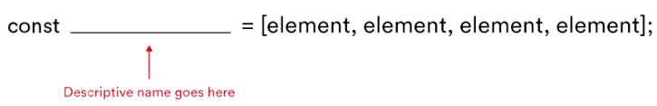

const beverages = ["coffee", "tea", "hot chocolate", "milk"];

const leapYears = [2016, 2020, 2024, 2028];

Arrays can also contain **different** datatypes;

const stuff = ["red", 42, "gorilla", false];

Arrays allow us to:

* Reorder elements.
* Identify the value of one element in a list by specifying its position.
* Go through a list item by item and manipulate each element.

Indexes

In an array, each element has an index, which tells us their order in the array. The first element has an index of [0], the second element has an index of [1], and so on.

Replacing an element in an array

Just write an assignment operator as below:

const characters = ['Darth Vader', **'Princess Leia'**, 'Han Solo', 'Luke Skywalker'];

characters[1] = 'Yoda';

//=> const characters = ['Darth Vader', **‘Yoda’**, 'Han Solo', 'Luke Skywalker'];

The Length Property

.length tells us how many elements are present in the array

['John', 'Paul', 'Mary'].length;

// => 3

const favoriteAthletes = ['Michael Jordan', 'Serena Williams', 'Babe Ruth', 'Muhammad Ali', 'Stephen Curry'];

favoriteAthletes[favoriteAthletes.length - 1];

// => 'Stephen Curry'.

favoriteAthletes[favoriteAthletes.length - 2];

// => 'Muhammad Ali'.

Push and Pop

const ghosts = ['blinky', 'inky', 'pinky'];

ghosts.push('clyde');

ghosts;

// => ['blinky', 'inky', 'pinky', 'clyde']

ghosts.pop();

ghosts;

// => ['blinky', 'inky', 'pinky']